Art - Architecture: Dream Big or Small?
Explore the responsibilities architects have to design us a better world. Make our own architectural mode.

DT - Design and sew a pencil case.

Geography
We will be exploring types of renewable and non-renewable energy sources, and assessing their pros and cons. We will locate them in the world and discover how they work. Using fieldwork at school, we will assess how well suited we are to one renewable source of energy.

P.E
Orienteering,
athletics and rounders.
French
Shopping vocabulary and questions involving school life and subjects.

Computing.
Game Creator – Pupils will review a successful game, design and create a game, and peer assess each others’ games.
Modelling - Pupils will design using 2D nets and build using 3D, using the 2Design programme.

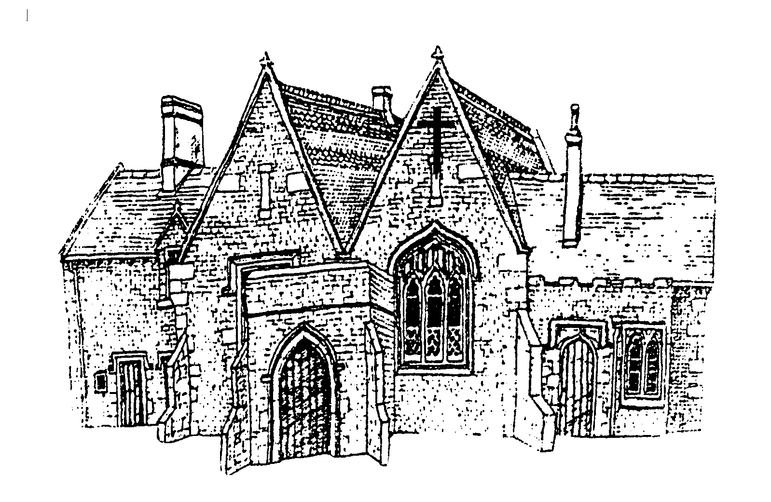
Cubbington CE Primary School
Year 5 - Summer Term 2024

Science – Properties of Materials
We will explore a range of materials and test their
properties in relation to heat and electric
conductivity, opacity and solubility.
Changes of Materials
Children learn how to explain changes in the
state of materials, and whether that change is
reversible or irreversible.

PSHE
Different influences: Drug, alcohol and tobacco education. Pupils learn:
• about the risks associated with smoking drugs, including cigarettes, e-cigarettes, shisha and cannabis
• about different influences on drug use – alcohol, tobacco and nicotine products
• strategies to resist pressure from others about whether to use drugs – smoking drugs and alcohol
Careers, financial capability and economic wellbeing: Borrowing and earning money
Pupils learn:
• that money can be borrowed but there are risks associated with this
• about enterprise
• what influences peopleʼs decisions about careers
RE - Hinduism and Christianity.
Children will explore Hindu beliefs and moral values, such as whether Karma, Samsara and Moksha help Hindus lead good lives. In Christianity, children consider what it means for Christians if God is holy and loving.
Music
Composing music based film music inspired by Harry Potter and developing skills on the recorder.

Other information

- Visit to Warner Brothers Studio – Friday 17th May 2024
- Y5 Class Assembly Wednesday – 5th June 2024
- Headteacher Celebration Assembly –17th July 2024

Literacy  Our text focus will be Flashbacks in the Harry Potter series, combined with a focus on film. Children will be asked to write in a wide range of genres, demonstrating their command of the grammar and punctuation that we have been learning this year. Other texts include Children of the Benin Kingdom by Dinah Orji and Anne Frank.  We will study comprehension skills regularly, where children work independently on a variety of texts.  Spelling strategies  to identify mis-spelt words in own writing;  to use known spellings as a basis for spelling other words with similar patterns or related meanings;  to use independent spelling strategies, including:  applying knowledge of spelling rules and exceptions;  building words from other known words, and from awareness of the meaning or derivations of words;  using dictionaries and IT spell-checks;  Spelling conventions and rules  learning and inventing spelling rules;  inventing and using mnemonics for irregular or difficult spellings;  unstressed vowel spellings in polysyllabic words;  to extend work on word origins and derivations from previous term. Use personal reading, a range of dictionaries and previous knowledge to investigate words with common prefixes, suffixes, word roots;  Grammar and Punctuation  Adverbs, adverbials, fronted adverbials, colons, bullet points and dashes, descriptive language using powerful adjectives and tenses including past perfect and imperative.  Reading  Year 5 pupils are encouraged to record their reading themselves. Your child will have a reading log to complete at school and can record reading at home, in their home/school diaries. They will be encouraged to change their library book regularly in line with Accelerated Reader. | Numeracy  Numeracy  Children will complete a combination of arithmetic fluency and problem solving, focusing on:  Adding and subtracting decimals  Calculations with money  Multiplying 3 and 4 digit numbers by 2 digit numbers (eg. 1234 x 16)  Multiplying fractions and converting between improper fractions and whole numbers.  Converting between fractions, decimals and percentages.  Learning to apply knowledge of fractions, percentages and ratio to problem solving.  Geometry, 3D shapes and their nets.  Co-ordinates, reflection and translation  Area and perimeter  Line Graphs and statistics  Times tables  We will continue to work on tables this term by mixing up the questions. Please help your child to work on these regularly and remember to use the PiXL Times Table App.
Home Learning…….. How you can help

The children will continue to receive weekly Literacy activities to be completed in their red home learning book. They will also have a spelling booklet showing the overview of spellings for the term. The children are expected to learn the list given for a weekly test.

The children will receive weekly online Maths activities and/or written activities to be completed in the blue home learning books. Regular times tables tests will also be set.

They will also be set Thematic home learning tasks once a term. Your child will generally receive a task list for each activity with a given out and hand it date. These will be collected in and monitored. Your child can do extra tasks, reading and research and will be rewarded for this. You can help by supporting your child to find and select appropriate resources from the library/internet to help them to complete the tasks.

